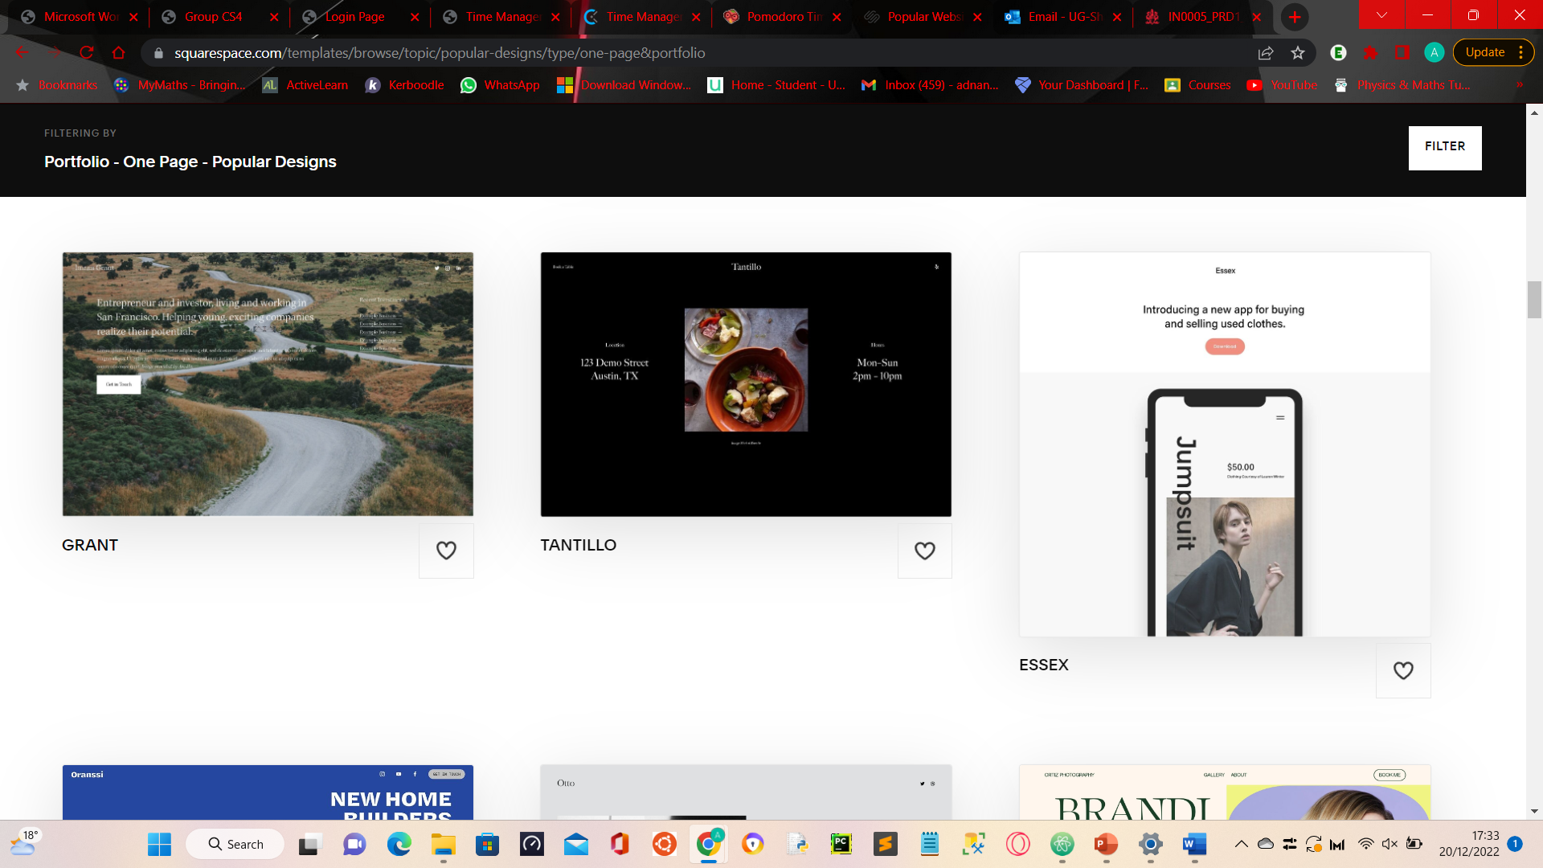



Personal Webpage

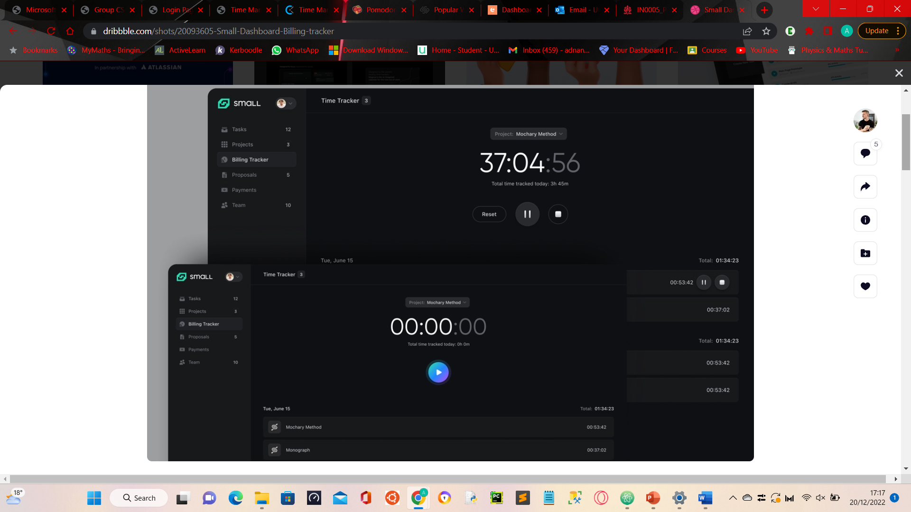

Time Management Dashboards